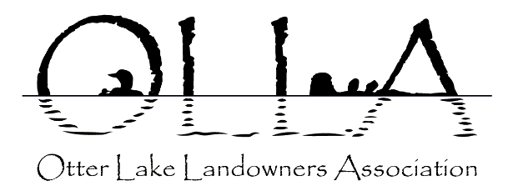
OLLA NEWSBYTES
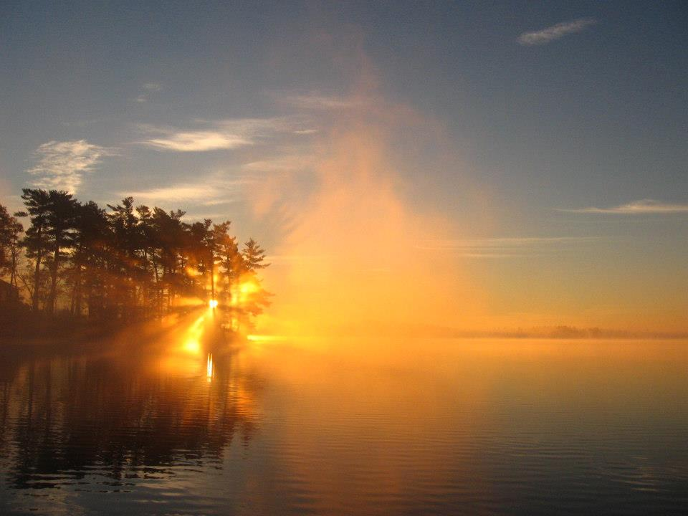
Visit our website: www.otterlake.org Edition: June 20, 2022
Follow us on Facebook: Otter-Lake-Landowners-Association

MEETING NOTICE – ANNUAL GENERAL MEETING
OTTER LAKE LANDOWNERS’ ASSOCIATION
DATE: Saturday, July 23, 2022 TIME: Registration : 9:00 AM, Meeting 9:30 AM
VENUE: South Elmsley Hall, Hwy. 15, Lombard
And we’re back! After two virtual Annual General Meetings, OLLA is happy to announce that we will be holding the 2022 AGM in person on July 23rd, 2022. We hope that you will be able to attend. Registration begins at 9:00 a.m. and the meeting will get underway at 9:30 a.m. Following the business portion of the meeting which includes election of directors to fill vacancies on the OLLA Board, presentations will include a short update on the Lake Plan and the Lake Steward’s Report. If you are concerned about attending the in person meeting, please contact Jeff Neal at ollapresident@otterlake.org
A light lunch and refreshments will be provided immediately following the meeting as was done at the 2019 AGM to provide everyone with an opportunity to mingle and speak with fellow attendees, and directors.
ANNUAL DUES: To participate in the AGM you must have paid your annual membership dues. If you have not paid yet, please email your $30 payment to otterlakeassociation@gmail.com or bring your payment to the AGM. If you are a new member or your contact info has changed you will need to complete a Membership Form (available on our website). If you are unsure of your 2022 membership payment status please contact John McKenney at INFO@otterlake.org .I
AGM AGENDA MEETING PACKAGE: A complete agenda package will be posted on the OLLA website www.otterlake.org seven days prior to the meeting. It will also be emailed to all OLLA members in good standing as outlined in the information above (Annual Dues). Should you know of someone that does not have email access and needs a hard copy please contact us or reprint a copy for them.
Agenda items will be the usual business items such as approval of the 2021 AGM Minutes, Treasurer’s Report, Membership Report, and Lake Steward’s Report. The election of directors will also take place, we currently have 6 openings.
CALL FOR NOMINATIONS – OLLA BOARD OF DIRECTORS: Currently we have eight directors on the board. There are four directors whose terms are completed and have put themselves forward for re- election. The OLLA Constitution allows for a maximum for 10 directors allowing for the possible election of two more directors.

Nominations are needed to fill these director positions. Please consider becoming a director or nominate someone you think would make a valuable addition to the OLLA Board. No experience necessary, just an interest in the stewardship of Otter Lake. Nominations can be made by sending an email to ollapresident@otterlake.org prior to the July 23rd AGM or from the floor at the meeting. Representation from the south and west shores of Otter Lake are encouraged.
If you have any comments or questions please direct them to Jeff Neal at ollapresident@otterlake.org.

Otter Lake Landowners’ Association
Annual General Meeting: Saturday July 23, 2022

Registration at 9:00 AM
MEETING WILL COMMENCE AT 9:30

AGENDA HIGHLIGHTS

- Membership, Lake Steward and Treasurer Reports
- Election of Directors (currently 6 openings)

If you are unable to attend the AGM and would like someone to represent you, please complete the section below and provide it to your delegate. She/he must bring this form to the AGM in order to be recognized as your designate.

VOTING BY PROXY FORM

My First and Last Name: ___________________________________

Cottage Number and Road: _________________________________
I designate: ____________________________________ to cast a vote on my behalf at the OLLA AGM on July 23, 2022.

Signature________________________________________
Note: Per the OLLA Constitution, a member attending the AGM can only accept a maximum of two proxies to be the designate for another member.

